CAREER COACHING CLIENT AGREEMENT

Please read the following terms and policies carefully regarding Golden Beacon USA’s Career Coaching Service. Sign your name and date at the end to signify your agreement to these terms.

This agreement is between ______________________ (herein referred to as ‘Client’) and Golden Beacon USA LLC (herein referred to as ‘Company’) and Laura Marenco (herein referred to as ‘Coach’) entered into on _______ (date). Golden Beacon USA LLC and Coach agree to provide the Career Coaching Service described below to Client. Client agrees to abide by all policies and procedures as outlined in this agreement as a condition of his or her participation in the Career Coaching Service. Company and Coach reserve the right to modify terms of this agreement at any time. All clients will be notified of any modifications.

INTRODUCTION

Golden Beacon USA LLC provides resettlement and acculturation services to immigrants and refugees to the United States. Among the services offered is career coaching wherein the Coach assists the Client in gaining new insight on challenges and opportunities they are facing in their professional lives. Coaching topics include, but are not limited to:
- Career planning/upward mobility/changing career fields
- Reviewing, editing, and/or creating resumes and cover letters
- Learning and practicing interviewing techniques
- Transitioning to a supervisory/management role at work
- Discovering interests and goals in order to make changes in one’s professional life
- Exploring and applying to job opportunities that align with one’s interests and goals
- Exploring higher education options and submitting applications

Each Career Coaching Package entails the following:
- An introductory meeting between Client and the Coach, either in-person or via phone, Zoom, or Skype
- Check-in meetings via phone, e-mail, in-person, Zoom, or Skype
- Work performed on behalf of Client outside of any Client-Coach meetings related to Client’s chosen topic. Examples include but are not limited to:
  - Searching for and researching jobs and/or industries
  - Creating, editing, or writing resumes and cover letters
  - Completing and submitting job applications
  - Contacting Coach’s network for leads
  - Researching educational programs and financial assistance
  - Creating user accounts for applications, and providing status e-mails to Client, such as application submission records or application user account information.
- All Coach-Client sessions are one-on-one and private.
- Client information is kept confidential.
- All sessions will be conducted in English. Coach speaks Spanish but is not fluent.
- It is the Client’s responsibility to alert the Coach of the need for an interpreter prior to the first meeting. Coach will provide an interpreter via phone as needed for those who struggle with the English language; however, Client is encouraged to bring his or her own interpreter if possible.
- The length of time the Coach and Client work together is limited to the number of sessions specified in the coaching package purchased by the Client. If the Client wishes to continue working with the Coach after all of the sessions from his or her package are completed, Client must purchase another coaching package before any work can begin.

DISCLAIMER

Coach is not a doctor, therapist, counselor, psychiatrist, or medical or other healthcare professional. Coaching is NOT a substitute for licensed counseling, medical advice, or substance abuse treatment. Counselors, therapists, and psychiatrists are trained to diagnose and treat mental health issues, such as depression and anxiety. Coaches help clients gain a fresh perspective on challenges or opportunities in their lives and find solutions on their own.

Coach does not diagnose or treat illnesses or provide medical advice. Client understands that Coach will not and shall not be obligated to act as a therapist providing psychoanalysis, psychological counseling or behavioral therapy. If Client is experiencing an emotional or mental health issue, Client should contact a licensed therapist, counselor or doctor.

EARNING DISCLAIMER
Every effort has been made to accurately represent the Career Coaching Service and its potential. The responsibility of the Coach is to adequately assess the needs and goals of the Client regarding his or her professional life. Coach assists the Client with realizing the obstacles and challenges that stand in the way of moving towards his or her desired outcomes and how to overcome them.
However, for the Coach-Client relationship to work, Client must also be committed to the Career Coaching process by fully participating. The desired outcomes from the Career Coaching Service, including earning potential, are entirely dependent on the Client’s efforts in collaboration with the Coach. Efforts include, but are not limited to: maintaining regular communication, completing tasks as assigned, showing up for sessions (whether in-person, virtual, or via phone), and being open to the Coach’s ideas and techniques.
Due to the nature of the hiring, employment, and school admittance processes in the United States, Client understands that use of the Career Coaching Service does not and will not promise or guarantee: (1) employment; (2) income generated from using any techniques and/or ideas provided by the Coach; (3) employment in Client’s preferred industry, location or job with a specific title; (4) admittance to any school or degree program; (5) employment and/or income generated from earning a credential (i.e. degree, certificate) in a certain subject or industry or from a specific educational institution; and (6) the receipt of any form of financial assistance for educational purposes, such as scholarships.

PAYMENT AND FEES
The Career Coaching Service is provided in 3 packages. Each package can be paid in full upfront or in 2 interest-free installments, with the second payment due one month from date of purchase. Client can choose service(s) from more than one topic for their package. (Selecting a specific topic is not a requirement for purchasing a coaching package). The three topics are: Career Planning, Job Search, or Education. Customizable packages that fit Client’s budget are available upon request.
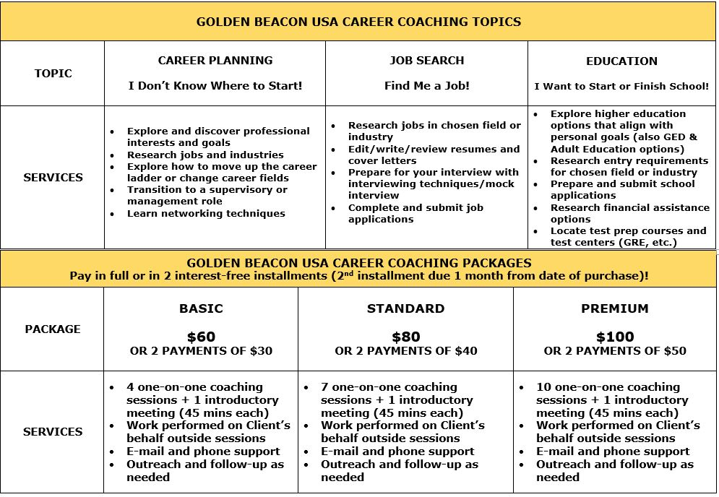
METHODS OF PAYMENT
Coaching package and installment plan (if applicable) must be purchased via goldenbeaconusa.com before any meetings or work can begin. Payment can be made via PayPal or credit card. Upon checkout, Client can either pay the full amount upfront or in 2 interest-free payments. Client’s credit card will be put on file and charged the second payment installment one month from date of purchase.

REFUND POLICY
In the event that Client decides that his or her purchase was not the right decision and notifies the Coach within 14 days from date of purchase (weekends and holidays included), Coach will provide Client with a 100% refund. If Client paid via installment plan but only paid the first installment, Client will receive a refund of his or her first payment and Client’s credit card will not be charged for the second installment. Client is encouraged to speak with Coach about resolving any issues or problems before requesting service termination. To request a refund, Client must contact Coach at laura@goldenbeaconusa.com or via phone at (866) 403-7173.
If Client requests a refund after 14 days from date of purchase (weekends and holidays included), Client is not entitled to a refund. If Client paid via installment plan, his or her credit card will not be charged upon termination of service for the second payment.

TERMINATION
Company (including for the purposes of this section, the Coach) is committed to providing all clients with a positive experience. By purchasing this Service, Client agrees that the Company may, at its sole discretion, terminate this Agreement, and limit, suspend, or terminate Client’s participation in the service at any time without providing a refund or forgiveness of due payments if Client becomes disruptive to Company or Coach, Client fails to participate in the Service, is difficult to work with, or upon violation of the terms as described in this agreement. Client understands that he or she can terminate this agreement at any time.

CANCELLATION AND RESCHEDULING POLICY
If Client needs to cancel or reschedule an in-person, virtual, or phone coaching appointment for any reason, Client is required to provide the Coach with 24 hours of notice by call or text at (866) 403-7173 or e-mail at laura@goldenbeaconusa.com and reschedule the session.

INDEMNIFICATION

Client agrees to defend, indemnify, and hold Company (including for the purposes of this section, its affiliates, subsidiaries, parents, successors and assigns, and each of its respective officers, employees, agents, owners, or the Coach) harmless from any claims, actions, suits, losses, costs, liabilities and expenses, including reasonable attorneys’ fees, relating to, or arising out of, or in any way connected to, the Career Coaching Service. Notwithstanding Client’s obligation to indemnify Company and/or Coach, Company will have sole control of the defense to any claim brought against it, in which case Client agrees to assist Company and cooperate in the defense to the claim.

DISPUTES RESOLUTION
Client agrees to attempt to resolve any dispute, claim, or controversy arising out of, or relating to these Terms, including its breach, interpretation, or validity, or use of the Career Coaching Service (each, a “Dispute”) by informal resolution. Client may contact Coach at laura@goldenbeaconusa.com or via (866) 403-7173 to notify Company and Coach about any Dispute.

LIMITED LIABILITY
IN NO EVENT WILL COACH OR COMPANY (INCLUDING, FOR THE PURPOSES OF THIS SECTION, ITS AFFILIATES, SUBSIDIARIES, PARENTS, SUCCESSORS AND ASSIGNS, AND EACH OF COMPANY’S AND THEIR RESPECTIVE OFFICERS, EMPLOYEES, AGENTS, AND OWNERS) BE LIABLE TO CLIENT FOR ANY INDIRECT, INCIDENTAL, PUNITIVE, SPECIAL OR CONSEQUENTIAL DAMAGES, INCLUDING BUT NOT LIMITED TO, DAMAGES, LOST PROFITS, OR LOSS OF EMPLOYMENT HOWEVER ARISING, AND WHETHER BASED IN CONTRACT, TORT, OR OTHERWISE, WHICH ARISE OUT OF OR IN CONNECTION WITH THE SERVICES OR THESE TERMS, EVEN IF COMPANY HAS BEEN ADVISED OF THE POSSIBILITY OF SUCH DAMAGES, AND EVEN IF THE REMEDIES UNDER THESE TERMS FAIL OF THEIR ESSENTIAL PURPOSE.
COACH OR COMPANY’S TOTAL AGGREGATE LIABILITY TO CLIENT ARISING OUT OF OR IN CONNECTION WITH THE SERVICE OR THESE TERMS SHALL NOT EXCEED (A) ANY UNDISPUTED AMOUNTS PAID TO COMPANY FOR WHICH A CLAIM ARISES; OR (B) ONE HUNDRED DOLLARS, WHICHEVER IS GREATEST.
COACH AND/OR COMPANY WILL NOT BE LIABLE TO CLIENT FOR ANY COMPENSATION, REIMBURSEMENT, OR DAMAGES ARISING IN CONNECTION WITH THE SERVICE OR FOR FAILURE OF THE COACH TO ATTEND A SCHEDULED CAREER COACHING SESSION DUE TO UNANTICIPATED CIRCUMSTANCES OR UNAVAILABILITY FROM ANY CAUSE BEYOND COMPANY AND COACH’S REASONABLE CONTROL.
LIMITATIONS OF LIABILITY OR EXCLUSION OF LIABILITY FOR INCIDENTAL OR CONSEQUENTIAL DAMAGES MAY NOT APPLY BY LAW WHERE CLIENT RESIDES, SO THE ABOVE LIMITATIONS OR EXCLUSIONS MAY NOT APPLY TO CLIENT. IN SUCH CASES, COMPANY’S LIABILITY WILL BE LIMITED TO THE FULLEST EXTENT PERMITTED BY APPLICABLE LAW.

By signing my name below, I acknowledge that I have read and agree to the terms set forth in this agreement.

Client’s Name (Please Print) | Client’s Signature | Date
Laura A Marenco
Coach’s Name (Please Print) | Coach’s Signature | Date

